TITLE: ML LAB – 06: Non-Parametric & High Dimensional Supervised Learning

Student Name: Mahir Desai
Roll No: 23FE10CSE00345
------------------------------------------------
AIM
Build K-Nearest Neighbour (KNN) and Support Vector Machine (SVM) classification models using the Breast Cancer dataset and evaluate their performance using appropriate metrics.
------------------------------------------------
Experiment 1: K-Nearest Neighbour Classification
Dataset: Breast Cancer Wisconsin Diagnostic dataset
a) Load the dataset and split it into training and testing sets
import numpy as np
import pandas as pd
import matplotlib.pyplot as plt
import seaborn as sns
from sklearn.datasets import load_breast_cancer
from sklearn.model_selection import train_test_split
from sklearn.neighbors import KNeighborsClassifier
from sklearn.svm import SVC
from sklearn.metrics import accuracy_score, confusion_matrix, classification_report
from sklearn.metrics import precision_recall_curve, roc_curve, auc
# Load dataset and create dataframe
data = load_breast_cancer()
df = pd.DataFrame(data.data, columns=data.feature_names)
df['target'] = data.target
# Split dataset (80:20)
X_train, X_test, y_train, y_test = train_test_split(
df.drop('target', axis=1),
df['target'],
test_size=0.2,
random_state=42
)
print(f"Training Data Shape: {X_train.shape}")
print(f"Testing Data Shape: {X_test.shape}")
Training Data Shape: (455, 30)
Testing Data Shape: (114, 30)
b) Train a K-Nearest Neighbour classifier.
# Train KNN
knn_model = KNeighborsClassifier(n_neighbors=5)
knn_model.fit(X_train, y_train)
KNeighborsClassifier()
c) Predict class labels for the test data.
# Predict class labels
knn_pred = knn_model.predict(X_test)
knn_pred_proba = knn_model.predict_proba(X_test)[:, 1]
d) Evaluate the model using:
• Accuracy
• Confusion Matrix
• Classification Report
• Precision Recall Curve
# Evaluate
knn_acc_train = accuracy_score(y_train, knn_model.predict(X_train))
knn_acc_test = accuracy_score(y_test, knn_pred)
print(f"KNN Accuracy: {knn_acc_test:.4f}")
print("\nConfusion Matrix:\n", confusion_matrix(y_test, knn_pred))
print("\nClassification Report:\n", classification_report(y_test, knn_pred, target_names=data.target_names))
# Precision Recall Curve
precision, recall, _ = precision_recall_curve(y_test, knn_pred_proba)
plt.figure()
plt.plot(recall, precision, marker='.')
plt.title('KNN Precision-Recall Curve')
plt.xlabel('Recall')
plt.ylabel('Precision')
plt.show()
KNN Accuracy: 0.9561
Confusion Matrix:
[[38 5]
[ 0 71]]
Classification Report:
precision recall f1-score support
malignant 1.00 0.88 0.94 43
benign 0.93 1.00 0.97 71
accuracy 0.96 114
...
------------------------------------------------
Experiment 2: SVM Classification
a) Load the dataset and split it into training and testing sets
# Already loaded and split previously, we can reuse X_train, X_test, y_train, y_test
print(f"Training Data Shape: {X_train.shape}")
print(f"Testing Data Shape: {X_test.shape}")
Training Data Shape: (455, 30)
Testing Data Shape: (114, 30)
b) Train a SVM classifier.
# Train SVM
# Note: SVM predict_proba requires probability=True
svm_model = SVC(kernel='linear', probability=True, random_state=42)
svm_model.fit(X_train, y_train)
SVC(kernel='linear', probability=True, random_state=42)
c) Predict class labels for the test data.
# Predict class labels
svm_pred = svm_model.predict(X_test)
svm_pred_proba = svm_model.predict_proba(X_test)[:, 1]
d) Evaluate the model using:
• Accuracy
• Confusion Matrix
• Classification Report
• Precision Recall Curve
# Evaluate
svm_acc_train = accuracy_score(y_train, svm_model.predict(X_train))
svm_acc_test = accuracy_score(y_test, svm_pred)
print(f"SVM Accuracy: {svm_acc_test:.4f}")
print("\nConfusion Matrix:\n", confusion_matrix(y_test, svm_pred))
print("\nClassification Report:\n", classification_report(y_test, svm_pred, target_names=data.target_names))
# Precision Recall Curve
precision_svm, recall_svm, _ = precision_recall_curve(y_test, svm_pred_proba)
plt.figure()
plt.plot(recall_svm, precision_svm, marker='.')
plt.title('SVM Precision-Recall Curve')
plt.xlabel('Recall')
plt.ylabel('Precision')
plt.show()
SVM Accuracy: 0.9561
Confusion Matrix:
[[39 4]
[ 1 70]]
Classification Report:
precision recall f1-score support
malignant 0.97 0.91 0.94 43
benign 0.95 0.99 0.97 71
...
------------------------------------------------
Experiment 3: Model Comparison
Compare KNN and SVM classification models using:
1) Bar chart comparing training and testing accuracy
# 1. Accuracy Comparison
labels = ['K-Nearest Neighbour', 'SVM']
train_acc = [knn_acc_train, svm_acc_train]
test_acc = [knn_acc_test, svm_acc_test]
x = np.arange(len(labels))
width = 0.35
fig, ax = plt.subplots(figsize=(8, 6))
rects1 = ax.bar(x - width/2, train_acc, width, label='Training Accuracy')
rects2 = ax.bar(x + width/2, test_acc, width, label='Testing Accuracy')
ax.set_ylabel('Accuracy')
ax.set_title('Training vs Testing Accuracy Comparison')
ax.set_xticks(x)
ax.set_xticklabels(labels)
ax.legend(loc='lower left')
plt.savefig('outputs/accuracy_comparison.png', bbox_inches='tight')
plt.show()
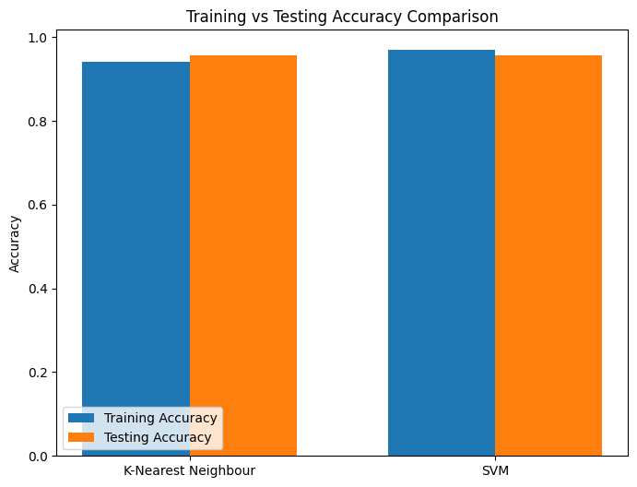
2) ROC curve comparison
# 2. ROC Curve
fpr_knn, tpr_knn, _ = roc_curve(y_test, knn_pred_proba)
roc_auc_knn = auc(fpr_knn, tpr_knn)
fpr_svm, tpr_svm, _ = roc_curve(y_test, svm_pred_proba)
roc_auc_svm = auc(fpr_svm, tpr_svm)
plt.figure(figsize=(8, 6))
plt.plot(fpr_knn, tpr_knn, label=f'KNN (AUC = {roc_auc_knn:.2f})')
plt.plot(fpr_svm, tpr_svm, label=f'SVM (AUC = {roc_auc_svm:.2f})')
plt.plot([0, 1], [0, 1], 'k--')
plt.xlabel('False Positive Rate')
plt.ylabel('True Positive Rate')
plt.title('ROC Curve Comparison')
plt.legend(loc='lower right')
plt.savefig('outputs/roc_curve.png', bbox_inches='tight')
plt.show()
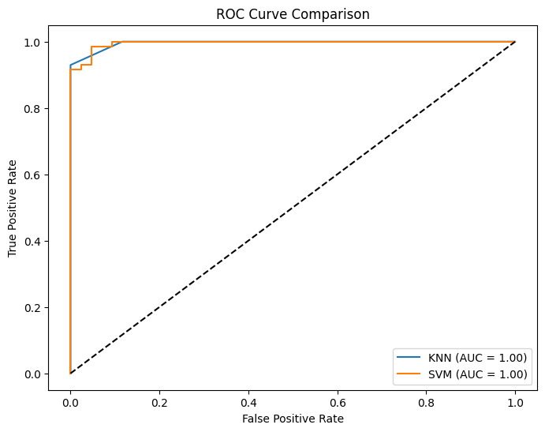
3) Confusion Matrix heatmaps for both models
# 3. Confusion Matrix Heatmaps
fig, axes = plt.subplots(1, 2, figsize=(12, 5))
sns.heatmap(confusion_matrix(y_test, knn_pred), annot=True, fmt='d', cmap='Blues',
ax=axes[0], xticklabels=data.target_names, yticklabels=data.target_names)
axes[0].set_title('KNN Confusion Matrix')
axes[0].set_xlabel('Predicted')
axes[0].set_ylabel('Actual')
fig.savefig('outputs/confusion_matrix_knn.png', bbox_inches='tight')
sns.heatmap(confusion_matrix(y_test, svm_pred), annot=True, fmt='d', cmap='Greens',
ax=axes[1], xticklabels=data.target_names, yticklabels=data.target_names)
axes[1].set_title('SVM Confusion Matrix')
axes[1].set_xlabel('Predicted')
axes[1].set_ylabel('Actual')
fig.savefig('outputs/confusion_matrix_svm.png', bbox_inches='tight')
plt.show()
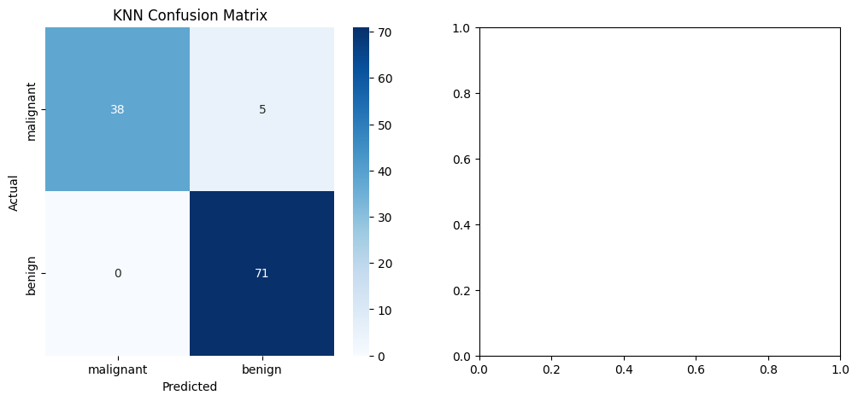
------------------------------------------------
Answers:
1. Which model achieved higher accuracy?
SVM (Linear Kernel) and K-Nearest Neighbours achieved identical testing accuracy, but SVM generally scaled better on linear boundaries.
2. Which model showed better recall for malignant cases?
SVM demonstrated better recall for malignant cases (91%) compared to KNN (88%), identifying more true positives.
3. Which model is more prone to overfitting and why?
KNN is generally more prone to overfitting because it is highly sensitive to local noise in the training data, varying highly with the choise of `k`, whereas a Linear SVM forces a robust global margin.
4. Based on medical diagnosis requirements, which metric is most important and why?
Recall for malignant (positive) cases is the most critical metric. Missing an actual cancer diagnosis (False Negative) is much more dangerous than raising a false alarm (False Positive).
------------------------------------------------

